The Management of Big Mountain Resort (Resort) has requested an analysis of the Resort’s pricing strategy. The focus will be on assessing overall price level as well as examination of four specific proposed strategies, namely:

1. Permanently closing down up to 10 of the least used runs. This doesn't impact any other resort statistics.
2. Increase the vertical drop by adding a run to a point 150 feet lower down but requiring the installation of an additional chair lift to bring skiers back up, without additional snow making coverage
3. Same as number 2, but adding 2 acres of snow making cover
4. Increase the longest run by 0.2 mile to boast 3.5 miles length, requiring an additional snow making coverage of 4 acres

The analysis consisted of a building a model using utilizing resort-level data (including Big Mountain Resort) focusing on individual resort characteristics. After validating the data, the analysis uses the weekend ticket price as a proxy for its pricing level comparisons across resorts.

Overall pricing strategy

With a current price of $81 and a modeled price of $99.83 (with a mean average error of $10.26), analysis of the data indicates that the Resort may be able to increase ticket prices, but further research should be conducted concerning the impact on ticket sales.

Comment on proposed strategies

**Proposed Strategy #1:** Model projections show that radical reductions in runs may produce a substantial reduction in pricing power though this may yield projected ticket prices closer to actual prices -- reductions in operating expenses should be examined closely.

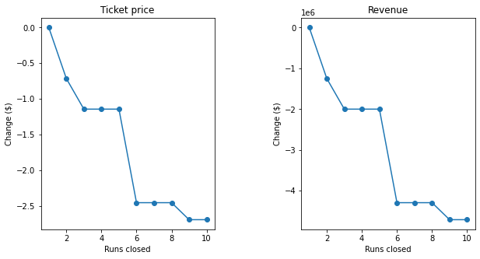

Projections show that minor reductions in the last two marginal runs have less than 1 USD per ticket in pricing power, Perhaps there are some runs that could be pruned that are relatively expensive to maintain and also have few customers. Management could try to set up cameras to record traffic on candidate runs to assess. Projections indicate that a reduction of tens runs would reduce ticket pricing power significantly, while likely reducing operating expenses minimally.

*Some variation of this strategy may increase profitability.*

**Proposed Strategy #2:** Analysis also indicates that increasing vertical drop as well as adding a corresponding chair together could provide some pricing power but projections indicate that operating costs ($1.5mm) will exceed the additional revenue ($1.0mm). Model projections aside, adding vertical drop to the bottom of the mountain may not yield the desired results, especially given the additional capital and operating expenses required. Adding vertical and a chair to a place where people don’t want to ski or ride may produce better model results rather than actual revenue.

*This strategy should be viewed skeptically.*

**Proposed Strategies #3 and 4:** Modeling indicates that marginally increasing both the length of the longest run and snowmaking coverage would yield no pricing power.

*These strategies should not be considered.*

Additional comments

In order allow for substantial increases beyond those modeled, there would likely have to be concurrent substantial increases in some of the key drivers. For example, projections show that an increase of 50 acres in snowmaking would allow for a 1 USD increase, while an increase of 60 acres in snowmaking would allow for a 5 USD increase. Again, the corresponding capital and operating costs would have to be carefully considered, but this seems to indicate that marginal increases have limited impact.

*Furthermore, since Big Mountain is already at the higher end of the pricing spectrum (and the highest in state), it may have limited ability to raise prices, regardless of the modeled projections.*

Finally, there are five areas where additional data help future modeling provide greater insight:

1. Mix between trail grade (e.g. beginner, intermediate, advanced, etc.) should be easily available by resort.
2. Granular operating and capital expenses: Overall operating revenues were provided but specific capital and operating expenses should be used. The more granular the better (industry v. state v. competitor cohort v. resort). Capital expenses are probably fairly constant but power and labor costs may vary significantly.
3. Advertising spend may be implied by the desire to add vertical at the bottom of the mountain, but would be interesting to understand how advertising and marketing drive revenue.
4. Daily ticket prices are provided but data on multi-day, season and discounted tickets should be examined as well as the overall number of ticket purchases.